Chad ONeal

08/12/2022

Web – 330 Assignment 1.3

Environment Setup

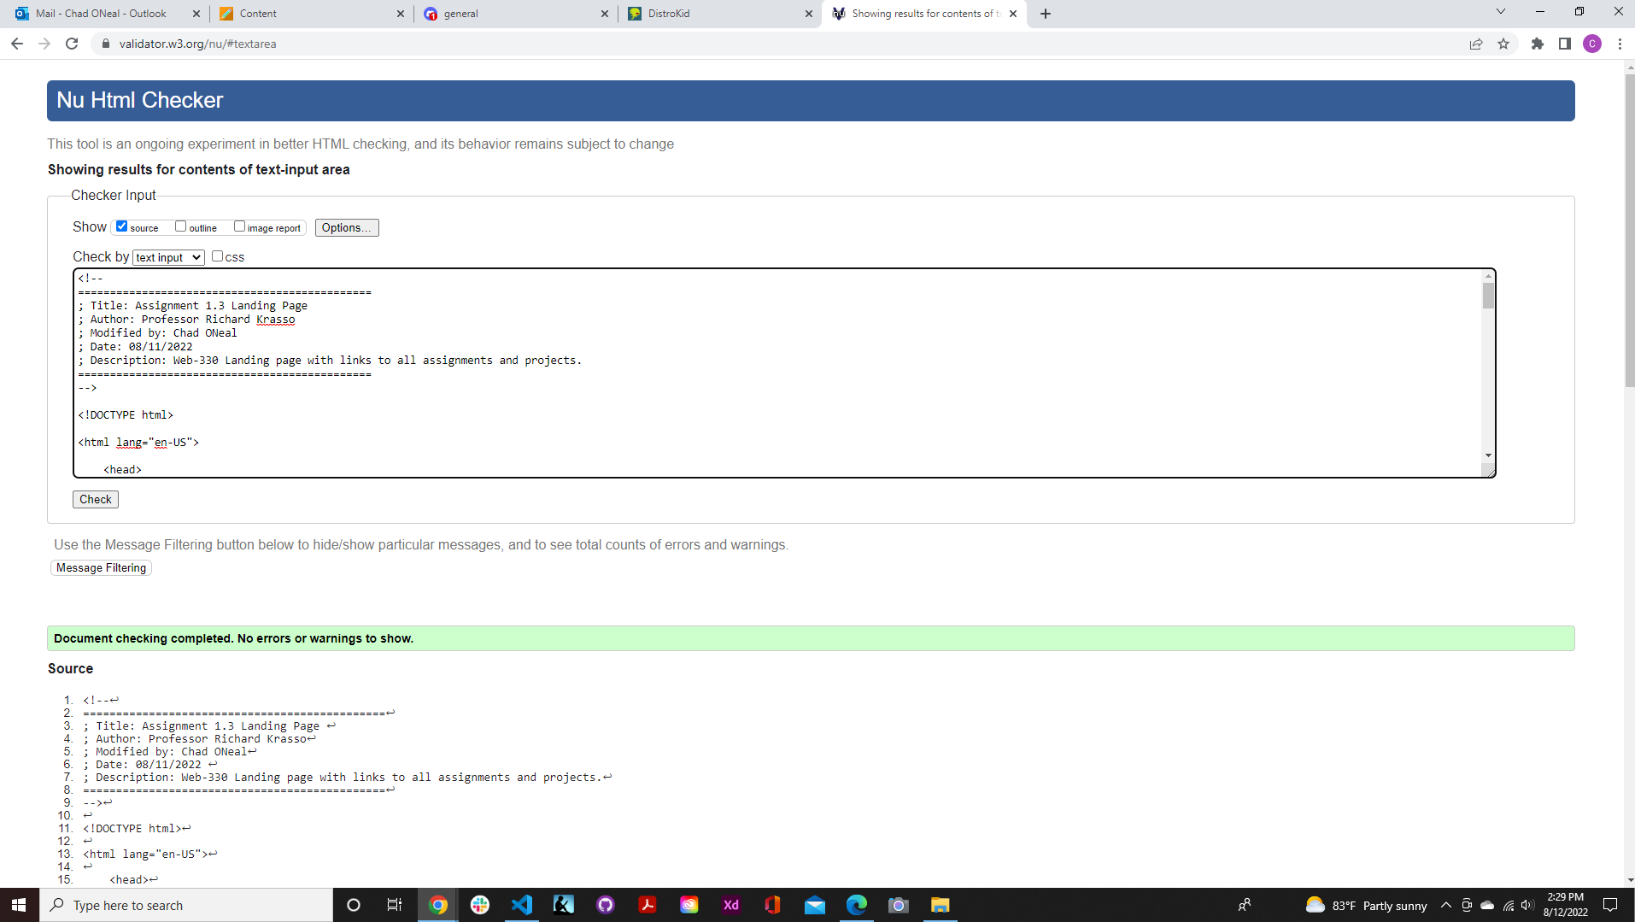

Site.css validation

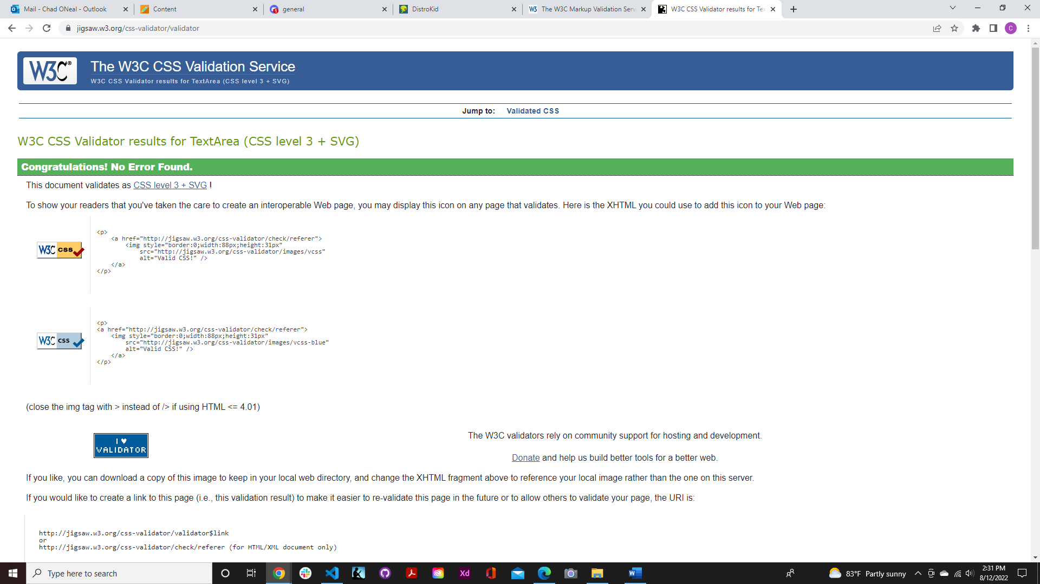

Theme.css validation

